A.KPI

1.Total Revenue

select sum(total_price) as total_revenue from pizza_sales

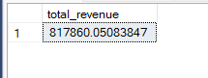

2.Average order values

select sum(total_price) / count(distinct order_id) as order_values from pizza_sales



3.Total pizza sold

select sum(quantity) as Total_Pizza_Sold from pizza_sales

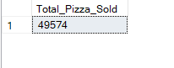

4.Total orders

select count(distinct order_id) as Total_Order from pizza_sales

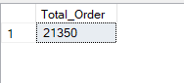

5.Average pizzas per order

select cast(sum(quantity) as decimal(10,2)) / cast(count(distinct order_id) as decimal(10,2)) as avg_pizzas_per_order from pizza_sales

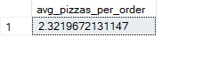

2.Charts

1.daily trend for total orders

select datename(dw,order_date) as order_day,count(distinct order_id) as Total_orders from pizza_sales group by datename(dw,order_date)

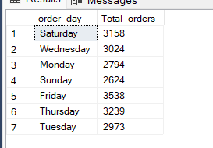

2.Monthly trend for total orders

select datename(month,order_date) as month_name ,count(distinct order_id) as total_orders

from pizza_sales

group by datename(month,order_date)

order by Total_Orders DESC

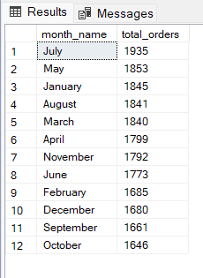

3.Percentage of sales by pizza category

select pizza_category, sum(total_price) as total_sales,sum(total_price) * 100 / (select( sum(total_price)) from pizza_sales) as percentage_total_price

from pizza_sales

group by pizza_category

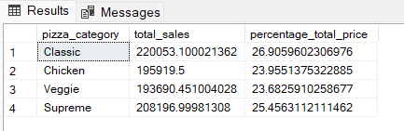

4. Percentage of sales by pizza size

select pizza_size,cast(sum(total_price) as decimal(10,2)) as total_sales,cast(sum(total_price) * 100 / (select( sum(total_price)) from pizza_sales where datepart(quarter,order_date) = 1) as decimal(10,2)) as percentage_total_price

from pizza_sales

where datepart(quarter,order_date) = 1

group by pizza_size

order by percentage_total_price DESC

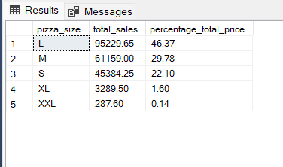

5.Top 5 pizza by revenue

select top 5 pizza_name,sum(total_price) as total_revenue from pizza_sales

group by pizza_name

order by total_revenue desc

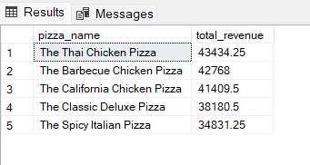

6.Bottom 5 pizzas by revenue

select top 5 pizza_name,sum(total_price) as total_revenue from pizza_sales

group by pizza_name

order by total_revenue asc

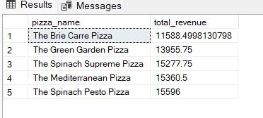

7.Top 5 pizzas by total orders

select top 5 pizza_name,count(distinct order_id) as total_orders from pizza_sales

group by pizza_name

order by total_orders asc

